**Core Java**

* **Java:**
  + Java is made by Sun Microsystems in 1995 and later on bought by Oracle and currently Java trademark is held by Oracle. Java is updated every 6 months.
  + Java is mainly used for Mobile development, Web development as well as Enterprise applications. Kotlin, Scala, Groovy come under java technology. Java is the most readable language, we can read code line by line and it is easy to understand.
  + Java has multiple features such as **WORA (Write Once Run Anywhere), multiple thread, Collection API concept, Exception handling and many more**.
  + Java is an object oriented programming language, so it means everything should be in an object and to create an object we need to have a class.
* **Setup Java Environment:**
  + **IDE:** To write Java, we can use Notepad and WordPad for simple programming but to work with java professionally, we can use different **IDEs(Integrated Development Environment)** such as **VS Code(Light weight editor), Eclipse and IntelliJ,** where we can type the code, compile the code, run the code and debug the code.
    - **VS Code URL:** [**VS Code**](https://code.visualstudio.com/)
  + **Compiler:** To compile the java code, we need to install **JDK (Java Development Kit)** 
    - **JDK URL:** [**Oracle JDK v24**](https://www.oracle.com/java/technologies/downloads/%23java24)
  + Once we complete the installation of IDE and JDK, to verify it, we can run “**JAVA --VERSION**” command to “**CMD**” and it will give you version of Java and JDK installed to the system also by running “**JAVAC --VERSION**” to get the current version and confirmed that compiler installed correctly.

* + While we check the versions and if we get an error then it means that path for java environment has not set up very well.
  + To set up environment variables, follow the following steps:
    - Start > Search “**Edit System Environment Variables**”
      * It will open below window, click on “**Environment Variables**”.

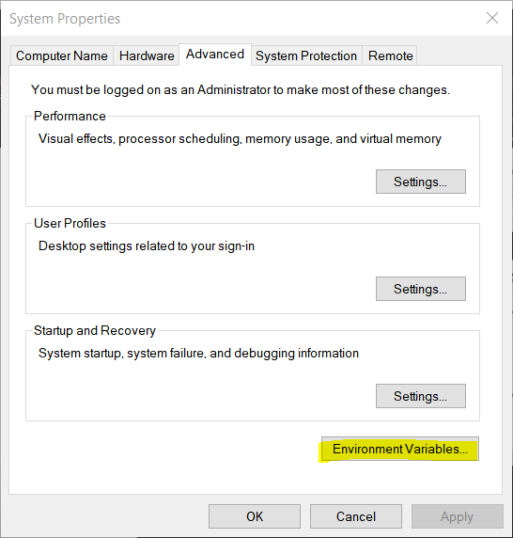

* + - * Select “path” and click on “**Edit…**” button under “**System variables**”

* + - * Click on “**New**” and add “**C:\Program Files\Java\jdk1.8.0_161\bin**” path or copy the path of **“…\Java\jdk1.8.0_161\bin**” then click “**OK**”.

* + - * Click on “**New…**” under “**User variables for…**” then add below values, and click on “**OK**” and “OK” for main window:
        + **Variable Name:** JAVA
        + **Variable value:** “**C:\Program Files\Java\jdk1.8.0_161\bin**” path or copy the path of **“…\Java\jdk1.8.0_161\bin**”

* **How Java Code Works on Backend:**
  + Java have JVM (Java Virtual Machine), using that we can run java application.
  + Under JVM there is OS (Operating System) comes and under that there is HW (Hardware).
  + Java is a platform independent, means when we write a Java code, it will run on any machine. Only this is required for it is that respective machine need to have JVM.
  + **JVM does not understand the Human readable code or instruction, but it accept only BYTE code. So, to convert this java code into Byte code it uses “Java Compiler”**
  + So, the basic flow is,
    - **Users create Java code > javac compiler compiled code to BYTE code > BYTE code goes on JVM > JMV look for “public static void main(String args[]” syntax to execute the code**.
  + In the real time scenario, there are 100s of files in the java project, so JVM starts with the first file/Main method file or file which contains main method file.
  + While running java code, it also requires some libraries and in java JRE (Java Runtime Environment) fulfill this request. Also, JVM is the part of JRE. JDK is only use by developers.
  + Main method contains one specific signature **“public static void main(String args[])”**

**(NOTE: In java there is only one Main method and only one file which have main method from where java code starts the execution.)**

* + As java follow WORA (Write Once-Run Anywhere), once developer develop application using JDK, and to use that application to other machine, we just have to install JRE and JVM (JDK does not required), and we can easily execute the code at any platform/OS.
* **Java Code Basic Code Structure:**
  + Java code file extension is **“.java”.**
  + Java code execution point is Main method of java where **“public static void main(String args[])”** main method comes.
  + To compile the code use **“javac FileName.java”** and it will create **“.class”** file.
  + Run code use **“java FileName”** command.
  + Java Basic Code Syntax:

* **Java Variables:**
  + Variables are used to store values, which can be either provided by the user, predefined or assigned during runtime.
  + **To define values in java, follow below syntax:**
    - DataType VariableName = Value;
    - **The value of variables also called LITERALS.**

**(NOTE: equal to ‘=’ is the assignment operator. It will take the value form right side and assigned to left side in variable.)**

* **Data types in Java:**
  + **There are 2 types of data types in java:**
    - Primitive data type
    - Non- primitive data type
  + **List of Primitive data type:**
    - **Integer**: Stores values without decimal point (0-9)
      * **Subtype of Integer:**
        + **byte**: supports 1 byte.

**Range**: -27 to 27-1 (-128 to 127)

* + - * + **short**: supports 2 bytes.

**Range**: -32,768 to 32,767

* + - * + **int**: supports 4 bytes.

**Range**: -2,147,483,648 to 2,147,483,647

* + - * + **long**: supports 8 bytes.

**Range**:-9,223,372,036,854,775,808 to 9,223,372,036,854,775,807

**(Note: While define, need to add “l” at the end of value.** Ex: long l = 12356l;**)**

* + - **Float**: Stores values with decimal point (0.0-9.0)
      * **Subtype of Float:**
        + **float**: supports 4 bytes.

**As Java define double as a default datatype, and we want to define float data type variable then we need to add “*f*” at the end of the value.**

**If we do not add “*f*”, then it will consider as double data type.**

**Ex:** *float fl= 5.6f;*

* + - * + **double**: supports 8 bytes.

**(Note: While defining decimal value variable, by default java supports “double” data type because while doing calculations, double data type store longer digits after decimal point then float.)**

* + - **Character**: Stores only single character (A’, ‘b’)
      * **Subtype of Character:**
        + **char**: supports 2 bytes.
        + **To define a character data type, we need to define value between single quotes (‘H’) because double quotes (“”) are only for String data type.**
        + **Also character data type stores only one single character.**
    - **Boolean**: Stores only either “**True**” or “**False**”
      * **Subtype of Boolean:**
        + **boolean**: supports 1 bit.
        + **In other programming languages, the values of boolean data type is 0 for false and 1 for true but in java the values are “True” or “False”**

**(NOTE: IF WE TRY TO STORE OUT OF RANGE VALES TO THE SMALL DATATYPE THEN IT WILL THROOW AN ERROR. FOR EXAMPLE, AS BYTE STORE (-128 to 127) RANGE AND IF WE STORE “129” IN IT, THEN IT WILL THROW AN ERROR.)**

* + **In integer data type, if we have long numbers, then we can add underscore (_) between the numbers while defining the values.**
    - **Ex: int num = 10_00_00_000;**
      * **Output = 100000000;**
  + **If we define a alphabet into the character data type then we perform the addition or subtraction operation, it will simply change the alphabet value**
    - **Ex: char c = ‘a’;**

**c++;**

* + - * **Output: b**

* **Data Type Conversion in Java:**
  + In java there are two techniques to convert a variable from one data type to another.
    - Type Conversion
    - Type Casting
  + **Type Conversion:**
    - Convert small data type into large data type without any data loss.
    - It is also known as **Implicit Casting** or **Widening conversion**.
    - Order of implicit conversion:
      * **byte -> short -> int -> long -> float -> double**
    - Example: Converting integer data type to double data type.
    - This type of conversion happens automatically because there is no risk of data loss.

* + **Type Casting:** 
    - Manually converting a large data type into smaller one.
    - It is also known as **Explicit Casting** or **Narrowing Conversion.**
    - It does not convert automatically because it leads to data loss.
    - Order of Explicit Casting:
      * **double -> float -> long -> int -> short -> byte**
    - Example: converting double data type to integer data type.
    - Syntax:
      * Big DataType Variable = Value;

SmallDataType VariableName = (SmallDataType) Value/BigDataTypeVariable;

